Shopez:one-stop shop for online purchases

* Project Title: Shopez:one-stop shop for online purchases
* Team Name: Code Crafters
* Team ID: LTVIP2025TMID41850
* Team Members:
Ramya Peluri – Frontend, Backend and implementation of project(Role)
Kolla Vivek – Frontend, Backend and implementation of project
Madiki Ram Surya Ganesh - NA
Durga Sai Mahesh Peyyala – NA

2. Project Overview
• Purpose:
The purpose of the ShopEZ project is to design and develop a full-stack e-commerce web application that simplifies and enhances the online shopping experience for customers while providing powerful tools for sellers to manage and grow their businesses. The project aims to deliver a user-friendly, secure, and scalable platform where users can effortlessly discover products, review detailed descriptions, view discounts, and complete purchases through a seamless checkout process.
For sellers, ShopEZ offers an intuitive admin dashboard for managing products, processing orders, and accessing analytics that provide valuable insights into business performance. The primary goals of the project include:
- Providing a smooth and engaging shopping experience for users.
- Enabling sellers to efficiently manage their products and orders.
- Supporting business growth through analytics and reporting features.
- Ensuring data security and reliable performance through modern technologies (React JS, Node.js, MongoDB).
- Demonstrating the effective integration of frontend, backend, and database systems in a full-stack application.
ShopEZ strives to create a future-ready e-commerce solution that benefits both customers and businesses.

2. Project Overview
Purpose:
To build a comprehensive online shopping platform that allows users to browse products, receive personalized recommendations, securely purchase items, and track their orders. At the same time, it enables sellers to manage their products and view sales analytics through a dedicated dashboard.
Features:
• User registration and login for customers and sellers
• Product listing, filtering, and detailed view
• Personalized product recommendations
• Add to cart and secure checkout process
• Order tracking and confirmation
• Seller dashboard for product and order management
• Admin dashboard for platform control
• Business analytics and insights for sellers
• Scalable and responsive UI design

3. Architecture
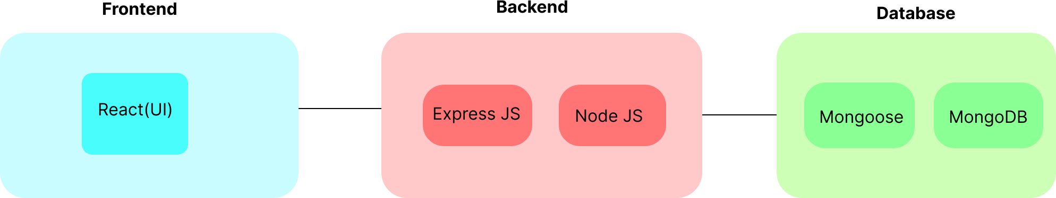

3.1 Frontend Architecture
- React.js: Used to build a responsive and dynamic user interface for both customers and sellers. It handles product browsing, cart management, and admin dashboard functions with high performance using the virtual DOM.
- Axios: Manages communication between frontend and backend through API calls for user login, product data, orders, and admin tasks.
3.2 Backend Architecture
- Node.js: Provides a fast, asynchronous runtime environment for processing API requests like user authentication, order handling, and product updates.
- Express.js: Serves as the backend framework to define routes and endpoints, making the backend modular and scalable.
- JWT Authentication: Ensures secure login and role-based access control for users, sellers, and admins.
3.3 Database Architecture
- MongoDB: A NoSQL database used to store collections such as Users, Products, Orders, and Cart.
- Document Structure:
  - Users: Contains user details and roles
  - Products: Holds item data, categories, and prices
  - Orders: Tracks order status and history
  - Cart: Temporarily stores selected items before checkout

4. Setup Instructions

PREREQUISITES:
To develop a full-stack e-commerce app using React JS, Node.js, and MongoDB, there are several prerequisites you should consider. Here are the key prerequisites for developing such an application:
Node.js and npm:
Install Node.js, which includes npm (Node Package Manager), on your development machine. Node.js is required to run JavaScript on the server side.
• Download: https://nodejs.org/en/download/
• Installation instructions: https://nodejs.org/en/download/package-manager/
MongoDB: Set up a MongoDB database to store hotel and booking information. Install MongoDB locally or use a cloud-based MongoDB service.
• Download: https://www.mongodb.com/try/download/community
• Installation instructions: https://docs.mongodb.com/manual/installation/
Express.js: Express.js is a web application framework for Node.js. Install Express.js to handle server-side routing,middleware, and API development.
• Installation: Open your command prompt or terminal and run the following command: npm install express
React.js: React.js is a popular JavaScript library for building user interfaces. It enables developers to create interactive and reusable UI components, making it easier to build dynamic and responsive web applications. To install React.js, a JavaScript library for building user interfaces, follow the installation guide:
https://reactjs.org/docs/create-a-new-react-app.html
HTML, CSS, and JavaScript: Basic knowledge of HTML for creating the structure of your app, CSS for styling,and JavaScript for client-side interactivity is essential.
Database Connectivity: Use a MongoDB driver or an Object-Document Mapping (ODM) library like Mongoose to connect your Node.js server with the MongoDB database and perform CRUD (Create, Read, Update, Delete) operations.
Front-end Framework: Utilize Angular to build the user-facing part of the application, including product listings, booking forms, and user interfaces for the admin dashboard.
Version Control: Use Git for version control, enabling collaboration and tracking changes throughout the development process. Platforms like GitHub or Bitbucket can host your repository.
• Git: Download and installation instructions can be found at: https://git scm.com/downloads
Development Environment: Choose a code editor or Integrated Development Environment (IDE) that suits your preferences, such as Visual Studio Code, Sublime Text, or WebStorm.
• Visual Studio Code: Download from https://code.visualstudio.com/download
• Sublime Text: Download from https://www.sublimetext.com/download
• WebStorm: Download from https://www.jetbrains.com/webstorm/download

To Connect the Database with Node JS go through the below provided link: •
Link: https://www.section.io/engineering-education/nodejs- mongoosejs-mongodb/
To run the existing ShopEZ App project downloaded from github: Follow below steps:
Clone the repository:
• Open your terminal or command prompt.
• Navigate to the directory where you want to store the e-commerce app. • Execute the following command to clone the repository:

Git clone: https://github.com/harsha-vardhan-reddy-07/shopEZ--e-commerce-MERN
Installation:
• Navigate into the cloned repository directory:
cd ShopEZ—e-commerce-App-MERN
• Install the required dependencies by running the following command:
npm install
Start the Development Server:
• To start the development server, execute the following command:
npm run dev or npm run start
• The e-commerce app will be accessible at http://localhost:3000 by default. You can change the port configuration in the .env file if needed.
Access the App:
• Open your web browser and navigate to http://localhost:3000.
• You should see the flight booking app's homepage, indicating that the
installation and setup were successful.

You have successfully installed and set up the ShopEZ app on your local machine. You can now proceed with further customization, development, and testing as needed.
5. Folder Structure

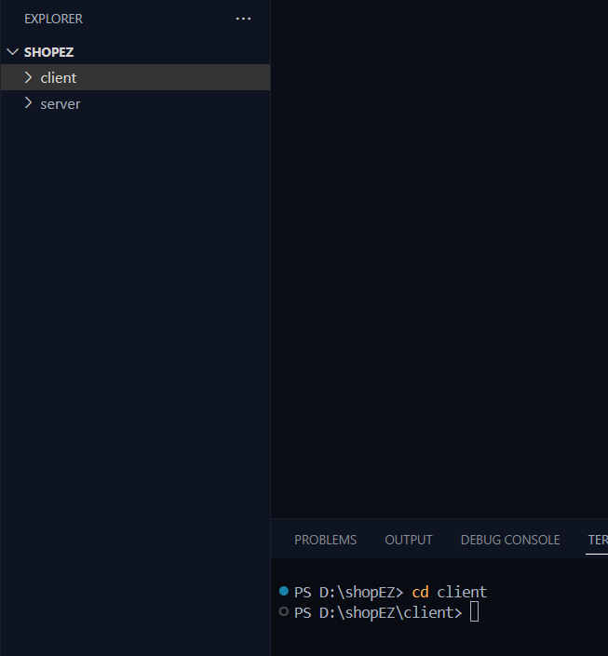

1. User Flow:
• Users start by registering for an account.
• After registration, they can log in with their credentials.
• Once logged in, they can check for the available products in the platform. • Users can add the products they wish to their carts and order.
• They can then proceed by entering address and payment details. • After ordering, they can check them in the profile section.

2. Admin Flow:
• Admins start by logging in with their credentials.
• Once logged in, they are directed to the Admin Dashboard.
• Admins can access the users list, products, orders, etc.,
• Client:
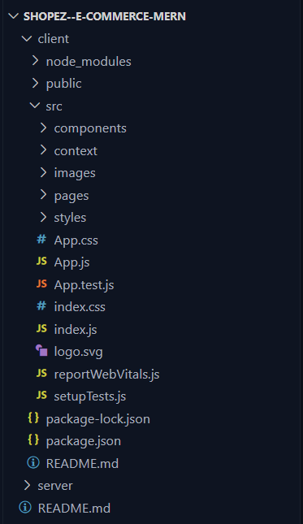

This structure assumes a React app and follows a modular approach. Here's a brief explanation of the main directories and files:
• src/components: Contains components related to the application such as, register, login, home, etc.,
• src/pages has the files for all the pages in the application.
• Server:
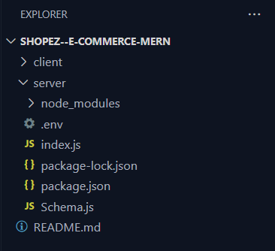

6. Running the Application

Commands to Start the Frontend and Backend Servers Locally
If node_modules folder is not present (for example, right after cloning the project), first install the dependencies.

→ Frontend (client directory)
. Install dependencies:
cd client
npm install
. Start the client:
npm start

→ Backend (server directory)
. Install dependencies:
cd server
npm install
.Start the server:
Npm start (or) node index.js

7. API Documentation
Method | Endpoint | Description
POST | /api/auth/register | Register a new user
POST | /api/auth/login | Login an existing user
GET | /api/products | Get all available products
GET | /api/products/:id | Get product details by product ID
POST | /api/cart | Add a product to the user's cart
GET | /api/cart/:userId | Get all cart items for a specific user
DELETE | /api/cart/:productId | Remove a product from the cart by product ID
POST | /api/orders | Place a new order
GET | /api/orders/:userId | View all orders made by a specific user
GET | /api/admin/orders | Admin: View all customer orders
POST | /api/admin/add-product | Admin/Seller: Add a new product
PUT | /api/admin/update/:id | Admin/Seller: Update a product by product ID
DELETE | /api/admin/delete/:id | Admin/Seller: Delete a product by product ID

Note: All protected routes require a valid JWT token in the Authorization header (e.g., Bearer <token>).
API Testing Tool: Postman

8. Authentication
- JWT-based authentication is used to secure all protected routes, ensuring only verified users can access sensitive features like placing orders or managing products.
- Tokens are stored in localStorage to maintain user sessions across page reloads, improving the user experience.
- Role-based authorization is implemented to differentiate between:
  - Admin: Full access to manage users, orders, and analytics
  - Seller: Access to product management and order tracking
  - Customer: Access to shopping, cart, and order history features

9. User Interface

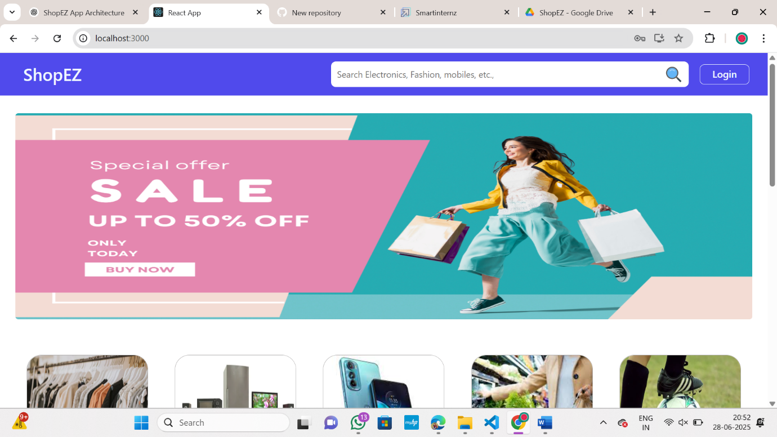
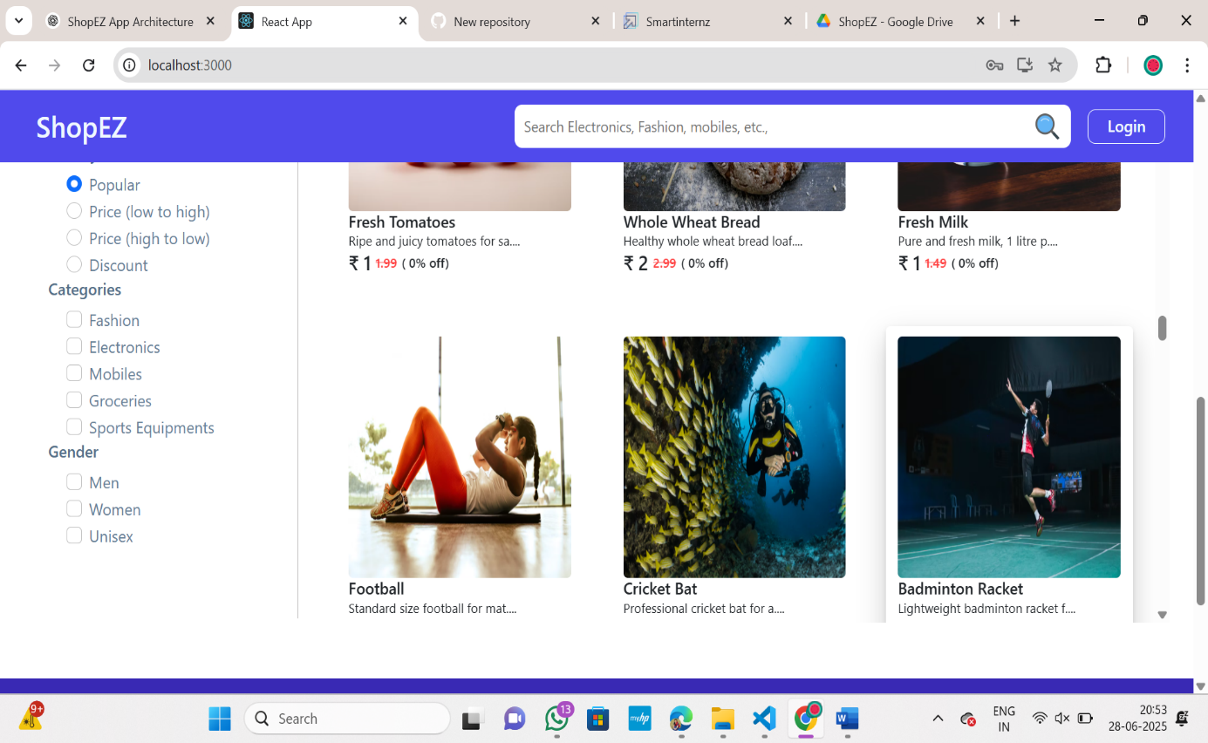

10. Testing

→ Testing Strategy:
The ShopEZ project adopts a combination of manual and automated testing strategies to ensure the reliability, functionality, and performance of the application. Testing covers both the frontend and backend components, focusing on key areas such as:
- Unit testing: Testing individual functions, components, and modules to verify they work as expected in isolation.
- Integration testing: Ensuring that the interaction between frontend, backend, and database is smooth and correct (e.g., placing orders, logging in, managing products).
- End-to-end (E2E) testing (optional/extendable): Simulating user flows across the full system, such as logging in, adding products to cart, and completing checkout.
→ Tools Used:
- Frontend Testing:
  - Jest: For unit testing React components and utility functions.
  - React Testing Library: For testing React components in a way that simulates user interactions.
- Backend Testing:
  - Jest or Mocha + Chai: For testing API endpoints and backend logic.
  - Supertest: For testing HTTP requests and verifying API responses.
- Manual Testing:
  - Browser-based testing across Chrome and Firefox for user interface and flow validation.
  - API testing using tools like Postman to verify API endpoints, authentication, and error handling.

11. Screenshots or Demo
1) Login and register page
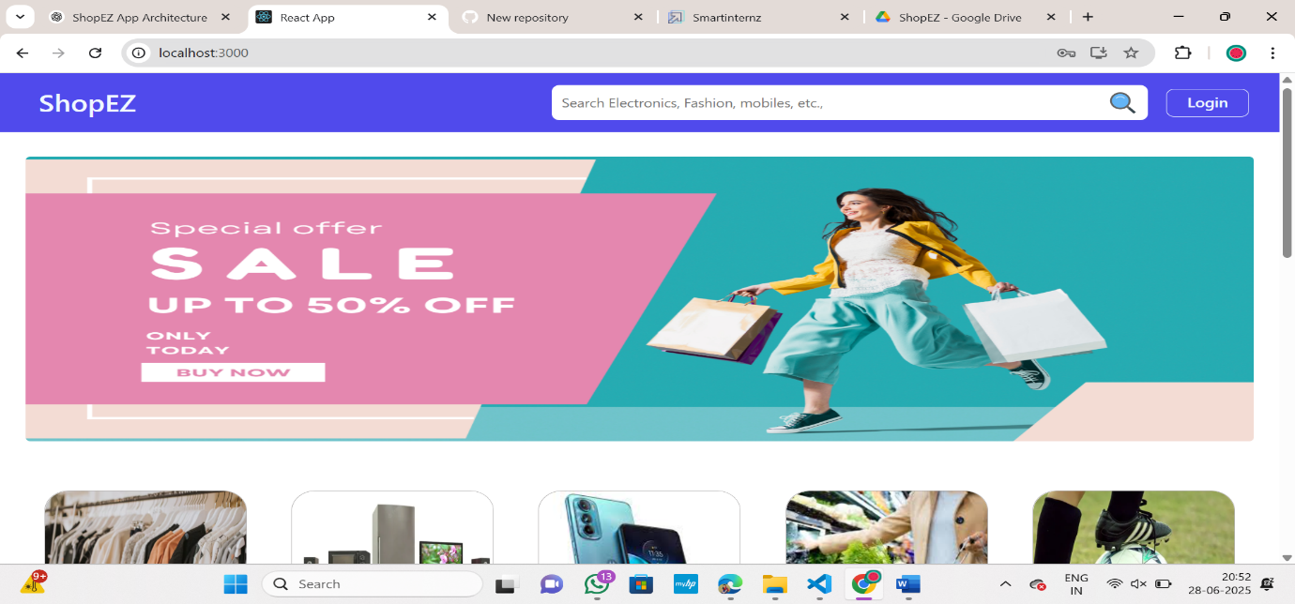
2)Filters
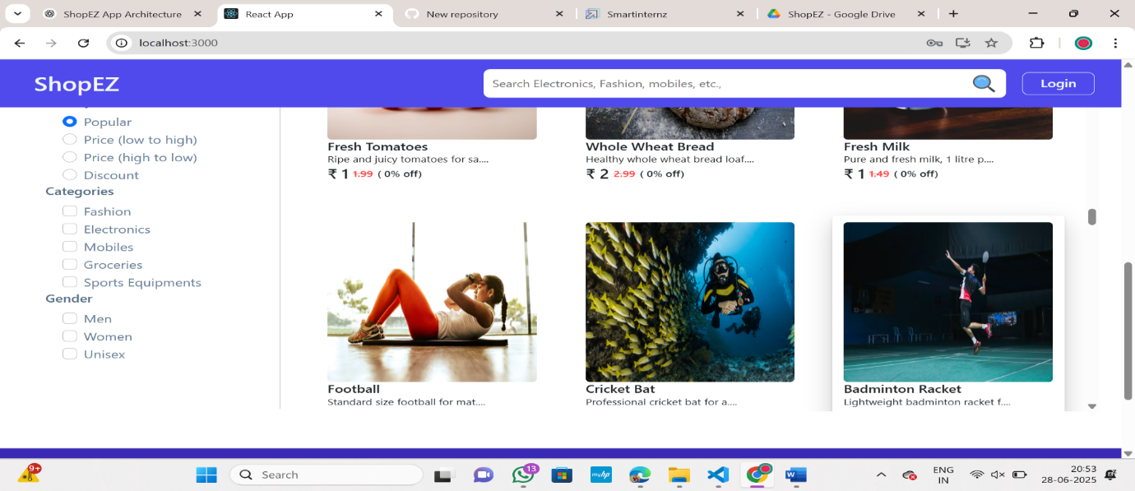
3)Register and login UI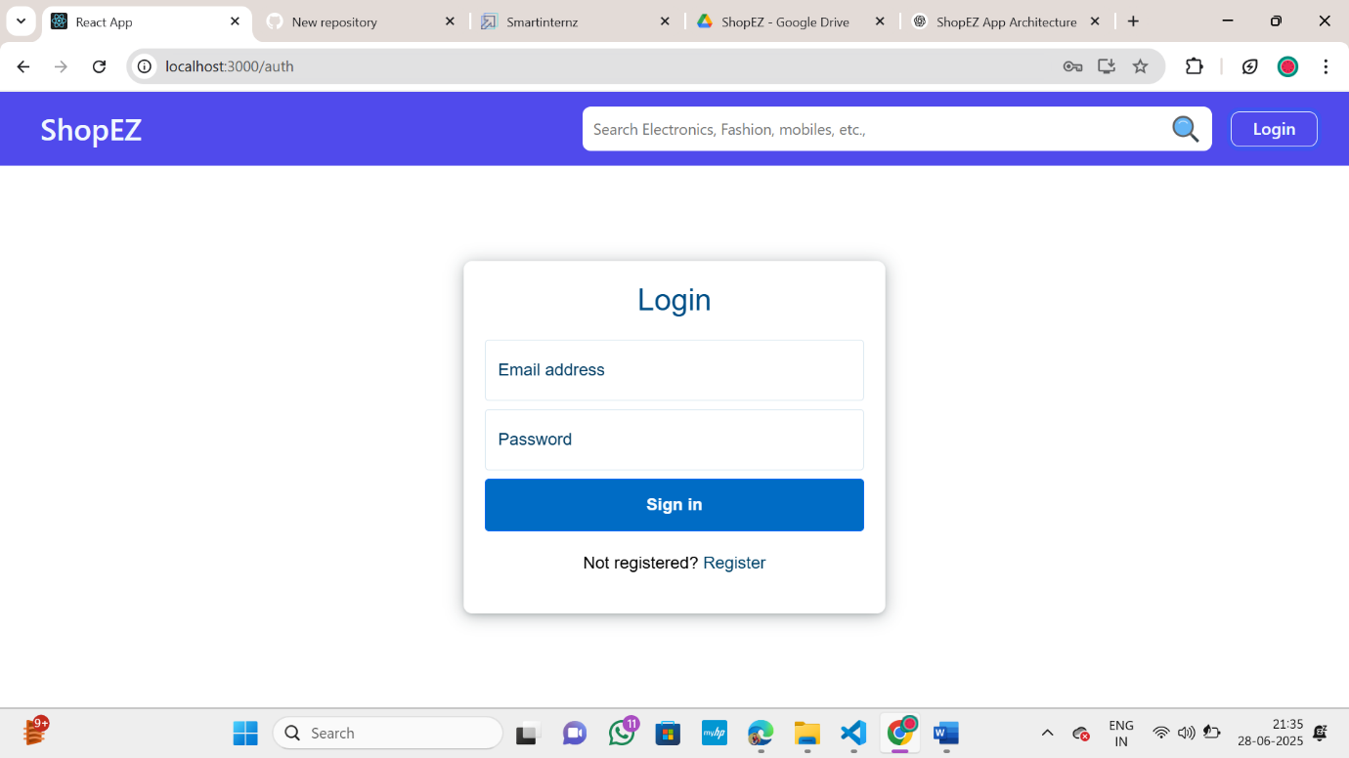

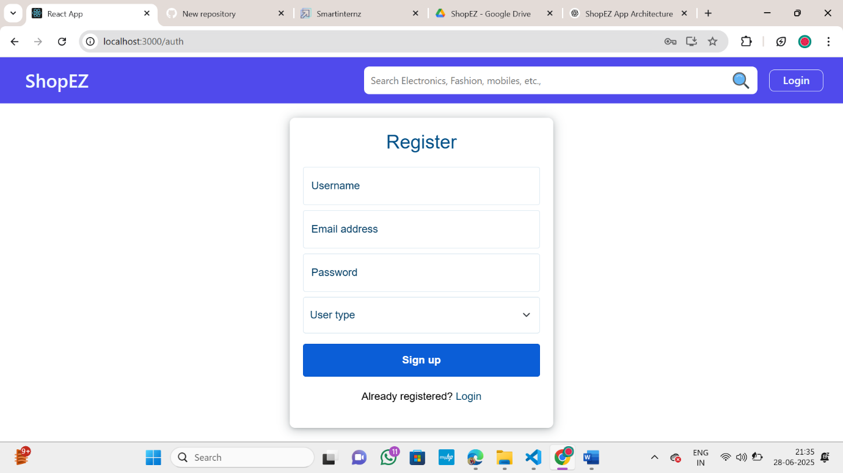

4)Admin dashboard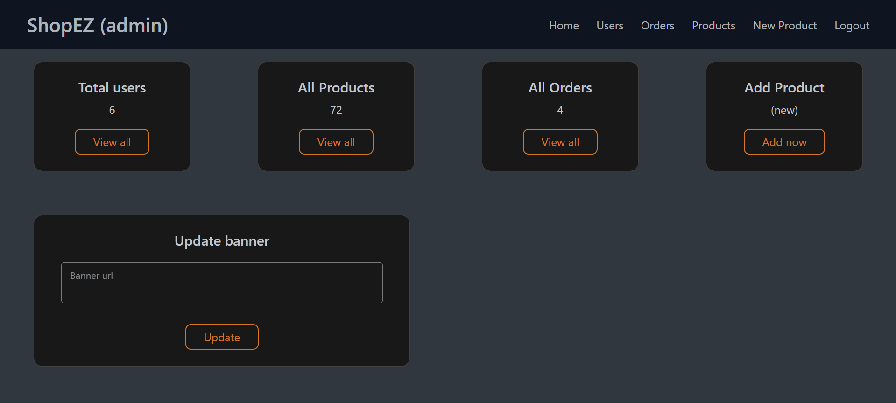

5)Orders receive
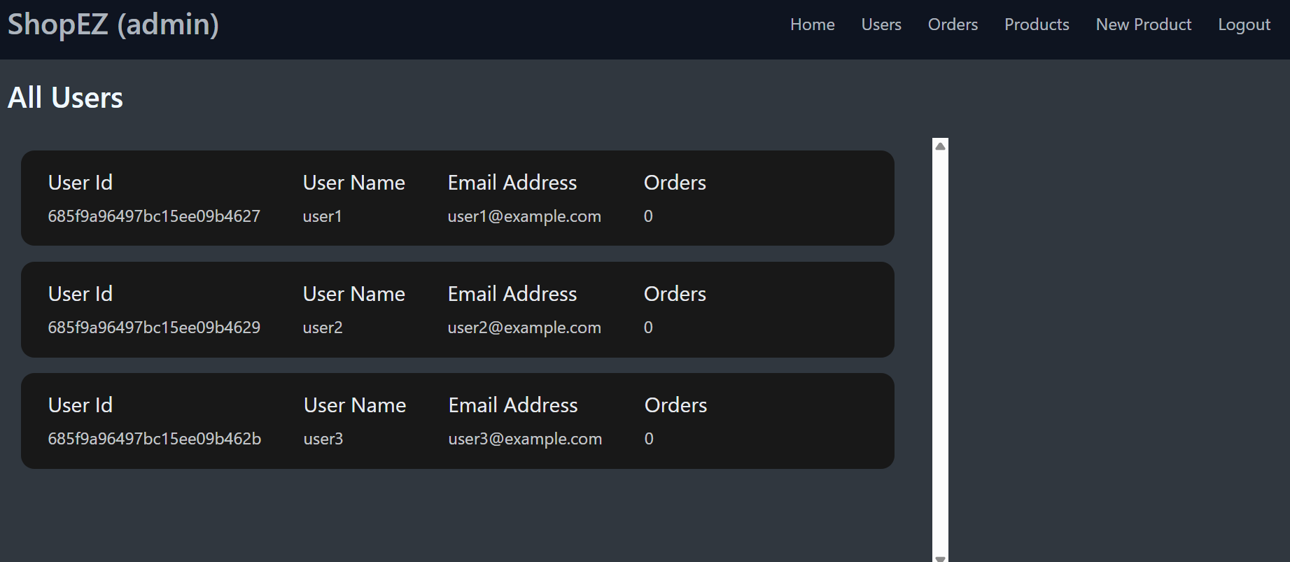
6)Mongodb Compass
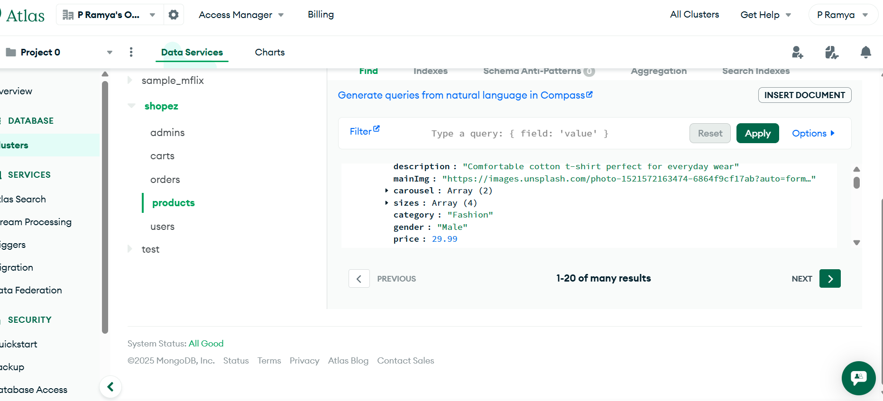

12. Known Issues
→ Responsive Design Limitations
- Some pages (e.g., admin dashboard or product management views) may not render perfectly on smaller mobile screens. Additional CSS adjustments are planned to improve mobile responsiveness.
→ Error Handling
- Certain API error messages (such as database connection failures) are generic. Detailed error reporting and logging mechanisms need to be enhanced.
→ Admin Role Management
- The current admin role system is basic. There is no support for multiple admin levels (e.g., super admin vs regular admin). This could lead to limited control granularity.
→ No Email Notifications
- Features like email order confirmations or password reset emails are not yet implemented. These are planned for future versions.
→ Cart Persistence
- The shopping cart is cleared on logout or browser refresh, as persistent cart storage (e.g., linked to user account in the database) is not yet implemented.
13. Future Enhancements
→ Persistent Cart Storage
- Implement cart persistence by saving cart items to the database so users can retain their cart across sessions and devices.
→ Email Notifications
- Add features to send email confirmations for orders, password resets, and promotional offers.
→ Advanced Admin Roles
- Introduce role-based admin levels (e.g., super admin, product manager, order manager) for better control and security.
→ Payment Gateway Integration
- Integrate real payment gateways (e.g., Razorpay, Stripe, PayPal) for secure and flexible payment options.
→ Search and Filter Improvements
- Enhance product discovery with advanced search options, filters, and sorting features (e.g., price range, rating, category).
→ User Profile Enhancements
- Allow users to update profile pictures, addresses, and preferences.
→ Analytics Dashboard (Advanced)
- Expand analytics for admins to include detailed sales trends, customer demographics, and inventory reports.
→ Mobile App Version
- Develop a mobile application (using React Native or Flutter) to complement the web app and reach a wider audience.

